EmbedUR module 2 linux assignments
- The linux environment
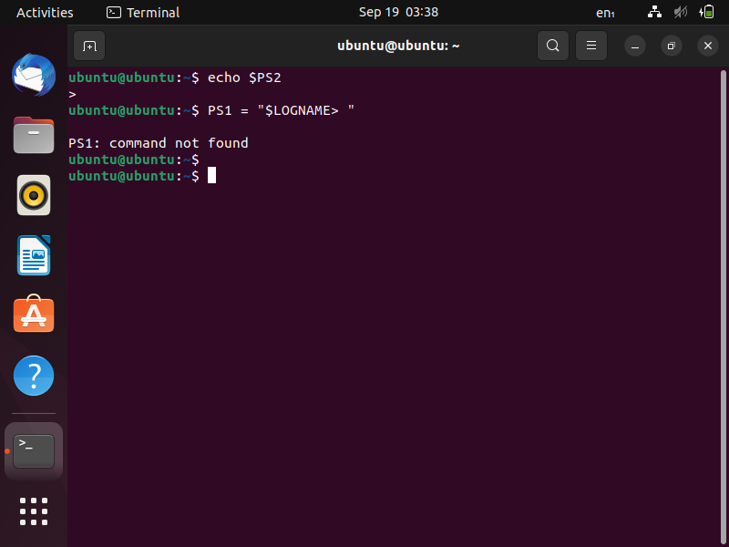
- Basics of system administration
Create a new user account and home directory called "Duck”new user account and home directory called "Duck"
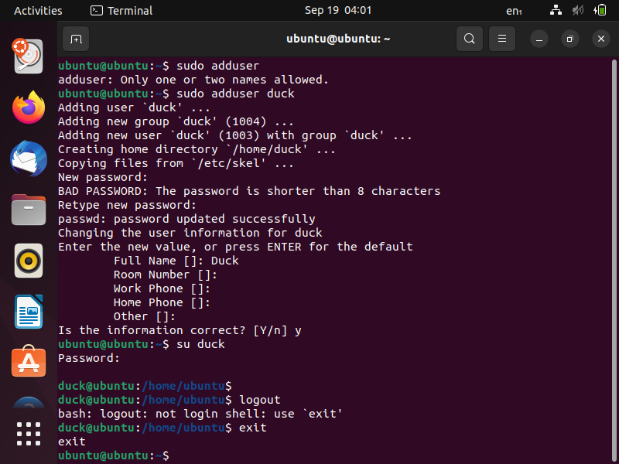
Set the user account "Duck's" expiry date as 07 - 01 – 2015. Find the id of the user account "Duck"
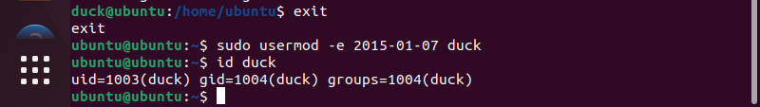

Type df and du commands and see the output on your terminal.
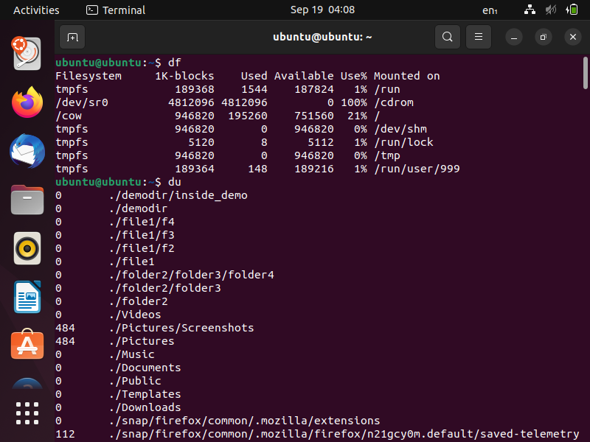

Type this command on the terminal and see the output :du -ch *.txt
Delete the user account "Duck" permanently along with its home folder.
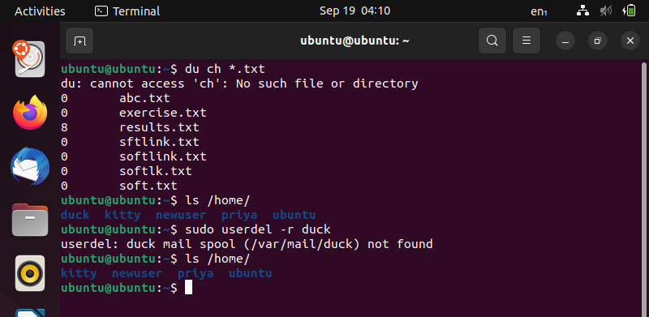
- Simple filters
Topic – head
Assignment i)
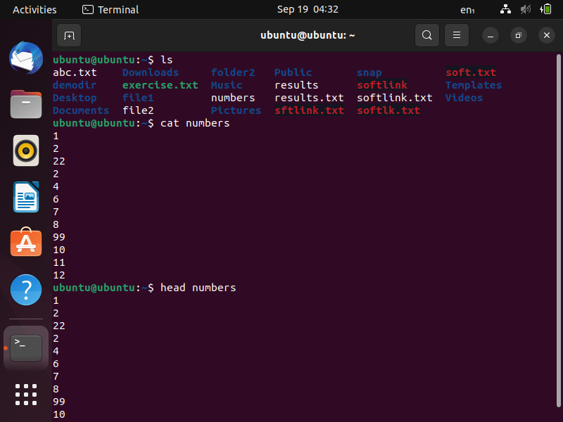
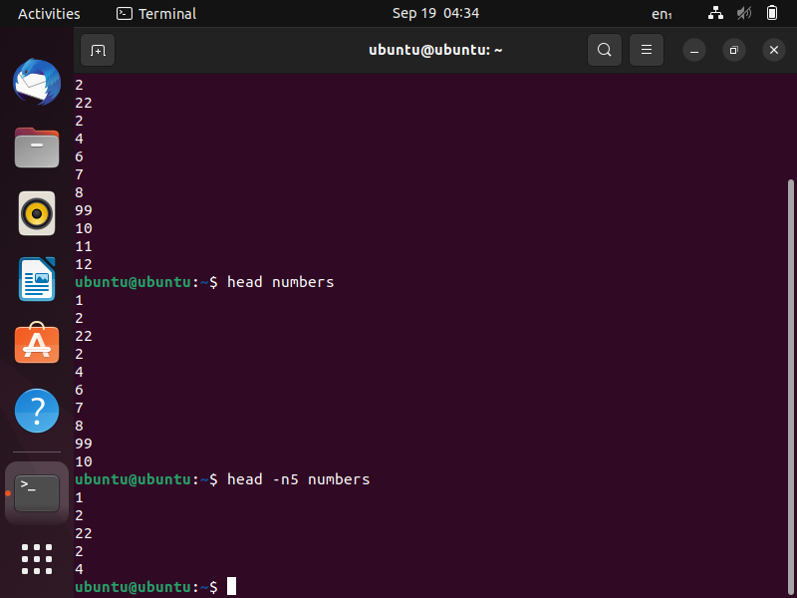
Assignment ii)
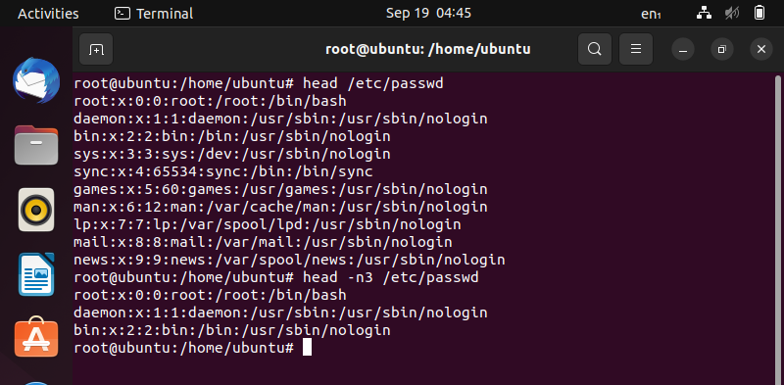
Topic – tail
Assignment i)
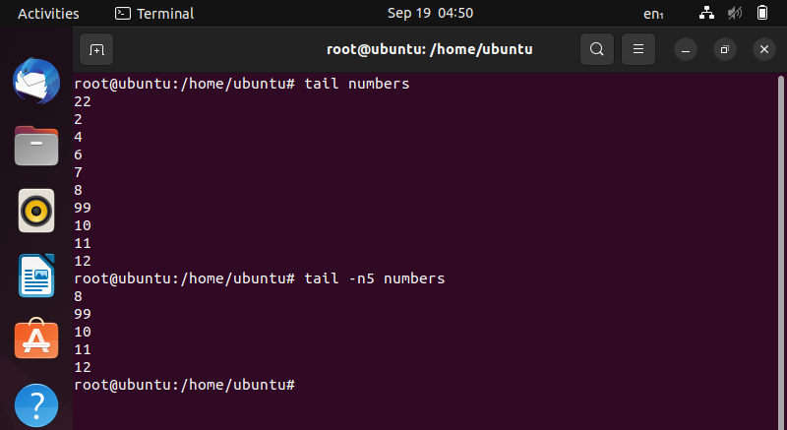
Assignment ii)
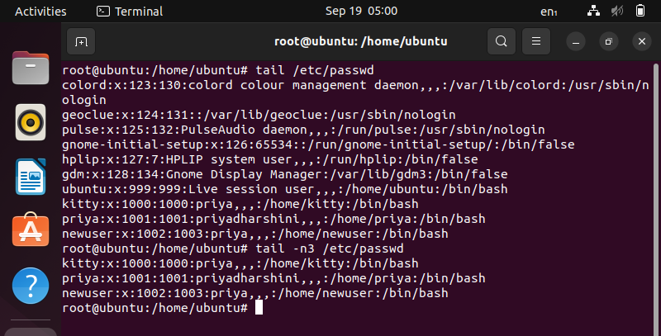
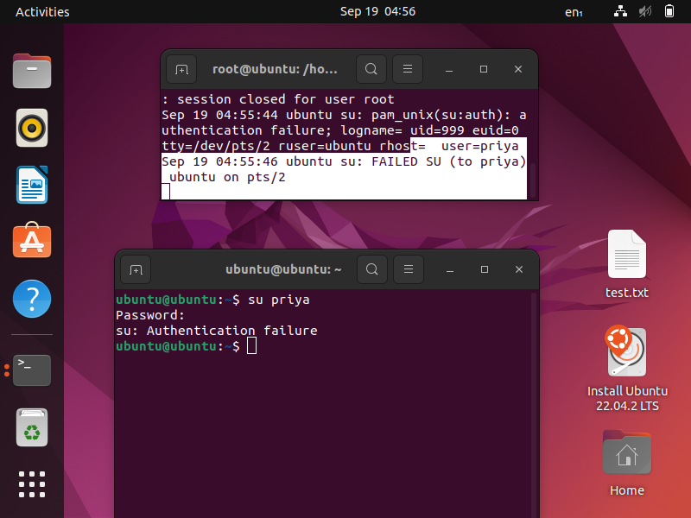
Topic – sort
Assignment i)
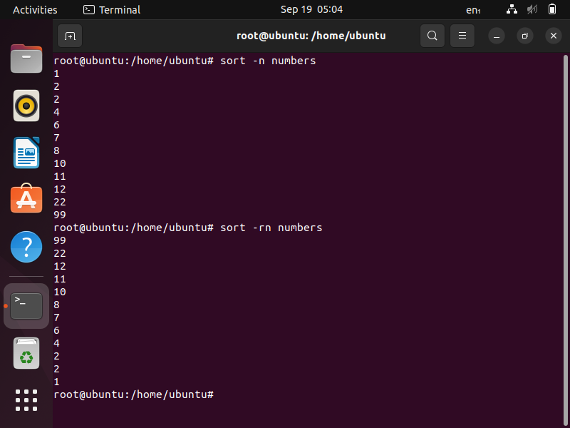
Sorting and removing the duplicates using –u option and sorting based on 2nd column
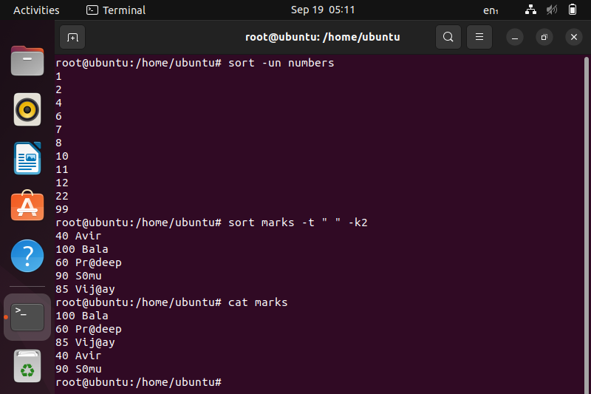
Assignment ii)
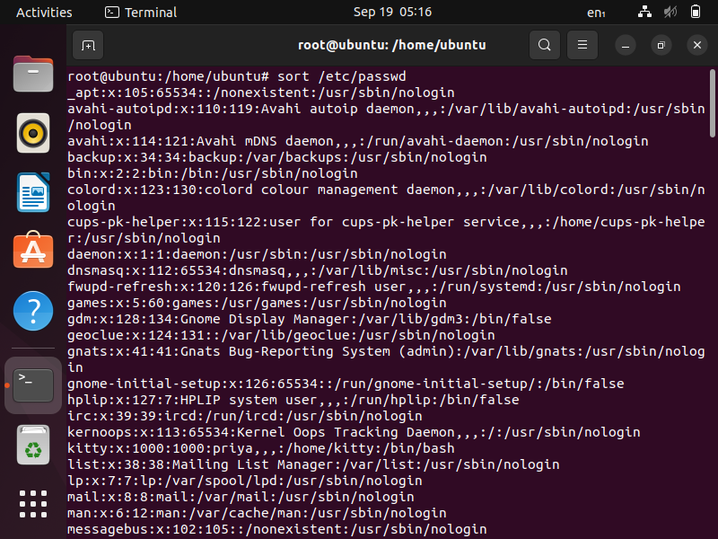
Topic – cut
Assignment i) and ii)
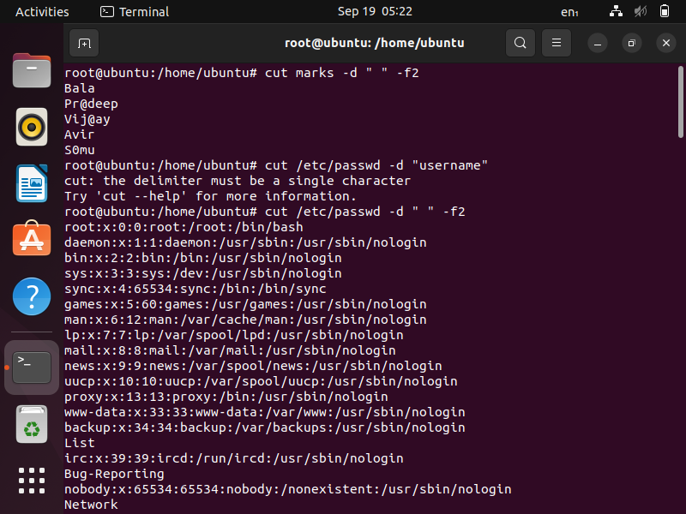
Topic – paste
Assignment i)
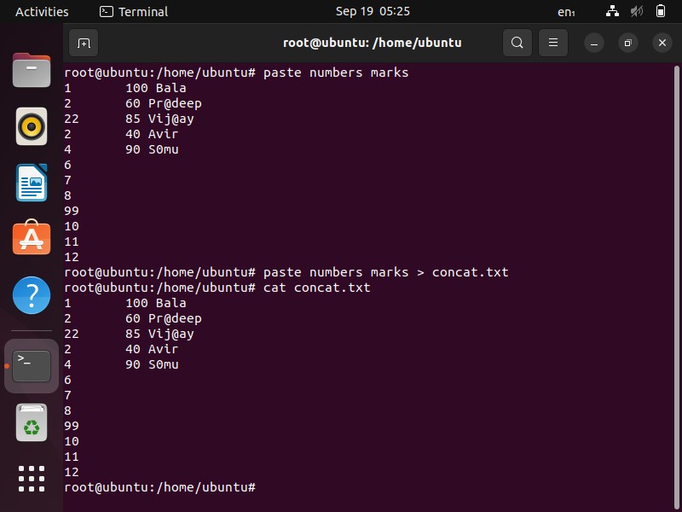
Assignment ii)
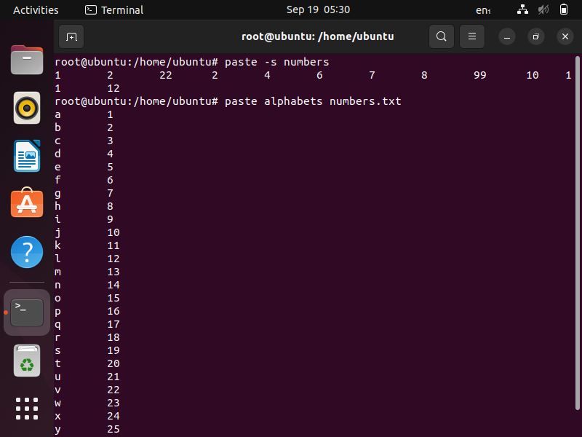
- The grep command
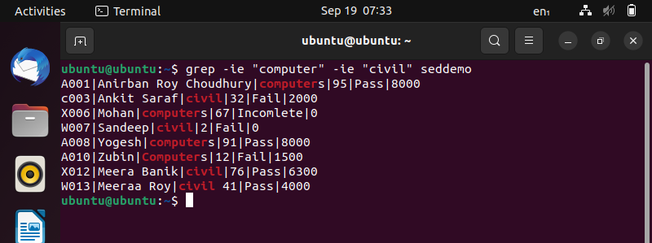
- More on grep command
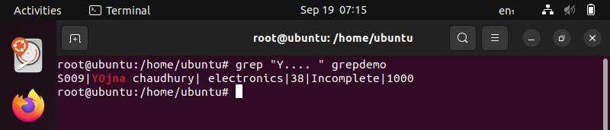

- The sed command
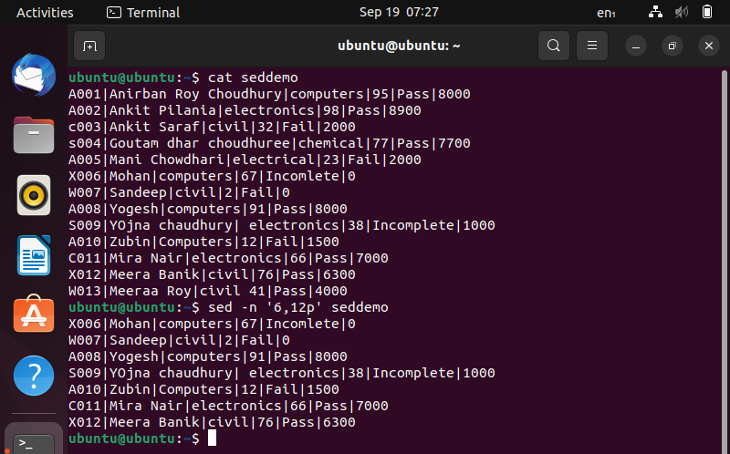
- More on sed command
